- director
- designer
- director>Jobs>OVEN_FTP
- 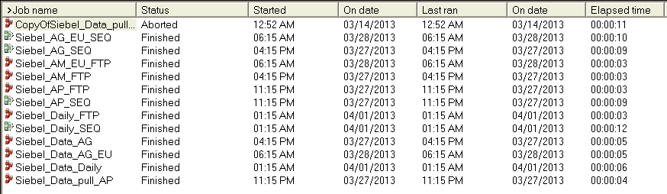
- the first job is
- to view schedule
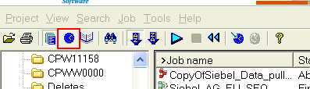
- Schedule
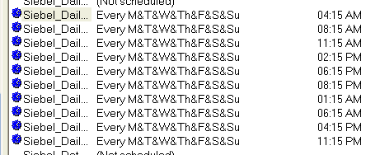
- to clear an aborted job just go to Job>Clear Status File
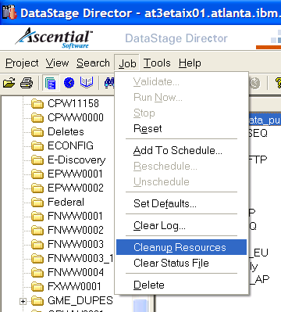
- in Designer double click on the marked job
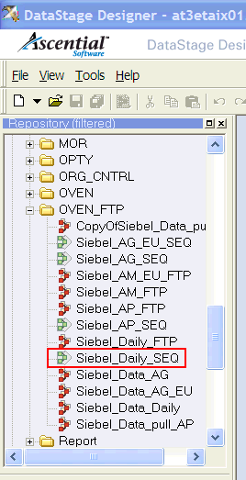
- Manual Run
a. clear the status in Director
b. go to designer
c. 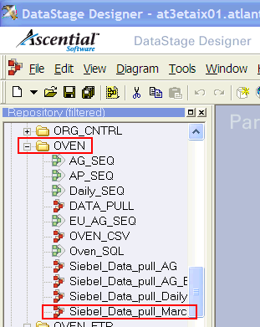
d. double click on Siebel_data_pull_march
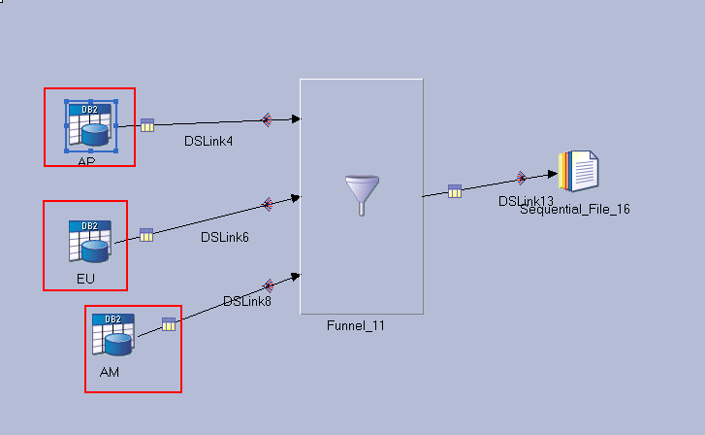double click on each of the Db Stage and change the SQL (date/time)
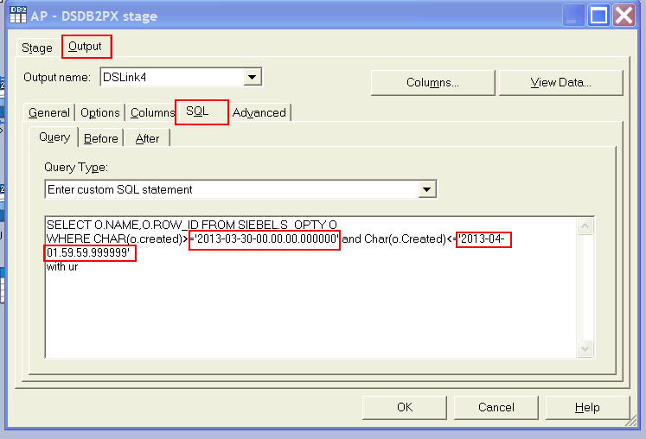

- for tracking
  - jobs are Tracking>Sales_stage_SEQ and Sales_Stage_SEQ_weekly
  - 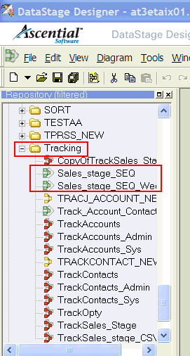

- User status: biweekly on Tuesday and thursday
  - 